Assignment 2

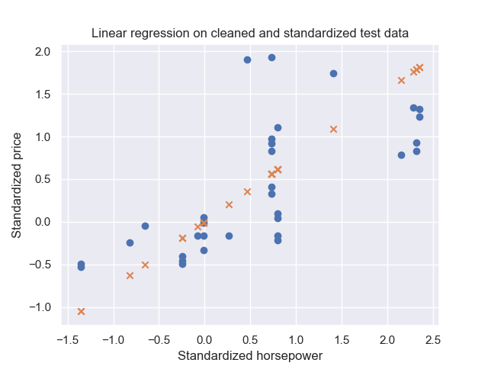

Parameter theta calculated by normal equation: (6.938893903907228e-17, -0.14578834426683027, 0.11275869144333475, 0.6469147504828134, -0.0038156096143426247)

Parameter theta calculated by SGD: (-0.00015145067037945615, -0.200080361179001, 0.271520372336242, 0.4110490271146563, -0.08773882590199188)

y1= 18.2339283 + -6.0512037 x + 1.1118855 x*x + -0.0798839338 x*x*x + 0.0027308 x*x*x*x + -0.0000376 x*x*x*x*x

Linear regression (order 5) score is: 0.8567469919905816

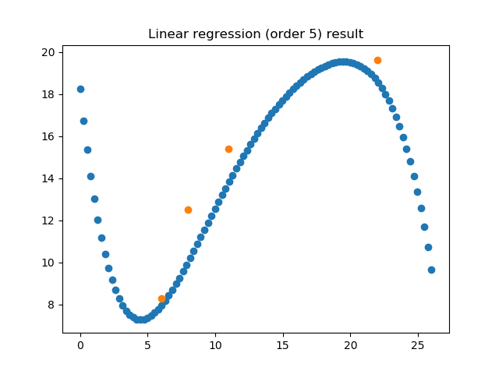

y2= 1.73612863e-01 + 4.14482301e-01 x + 3.33554347e-01 x*x + -4.35769907e-02 x*x*x + 2.32665803e-03 x*x*x*x + -4.56611443e-05 x*x*x*x*x

Ridge regression (order 5) score is: 0.9997795899731411

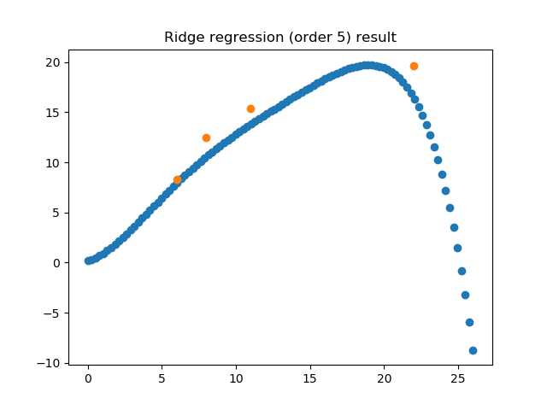

Q1: Which model has the highest score?

Ans: Ridge regression (order 5)

Q2: Does a larger result in a larger coefficient for x5 in the regression equation in Ridge model (order 5)?

Ans: No

Q: Does the predictions of X_test contain values other than 0 or 1?

Ans: No

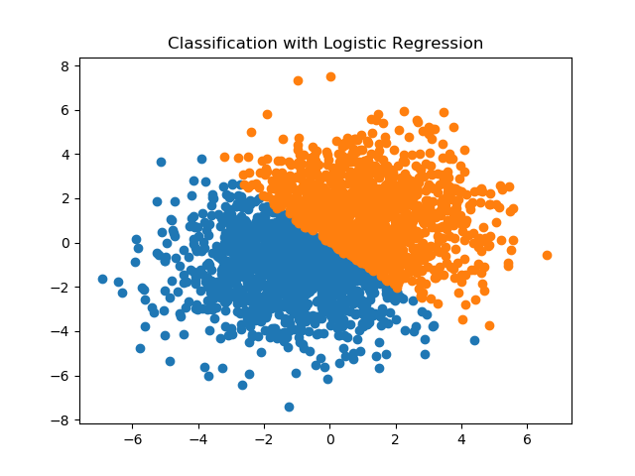

Number of wrong predictions is: 550